Some Best Practices for Social Media
- Craft short, to the point messages that can be copied and pasted. Encourage members to personalize the message, especially with their own experiences.

- Provide the actual links to the actual contact pages of legislators if using email.

- If asking members to phone provide the phone number and the message.

- If using social media to communicate with members, don’t assume members know how to use what you provide. Show them.

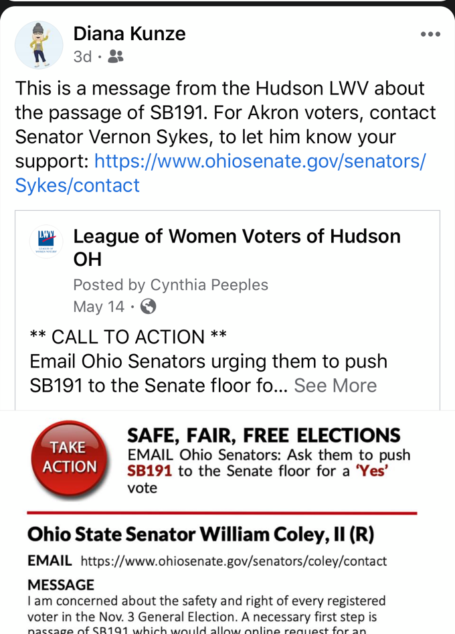
Note message. Diana is Hudson League but lives in Akron. She made it applicable to her personal Akron friends. This could be more personal. This example is from LWVH action, but all posts will be coming from LWVO. They then can be shared on local League pages as well as personal pages.

- Ask members to share the messages you put up on social media. They need to share it with a personal message in order to get it out into their network.

Longer message, but if person doesn’t click, the important pieces are just below.
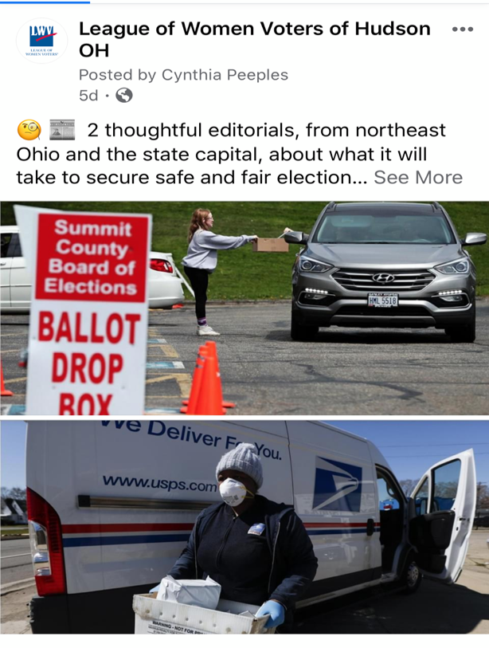

- Challenge members not only to take action, but to get the message out for action to 5 of their friends and report back to you when they have.

- Connect articles to the message when possible.

While these examples deal with Facebook, you can accomplish the same thing using an email campaign to reach your membership. Encourage the emails to be forwarded to friends with personal messages.

